SHARP COLOURS
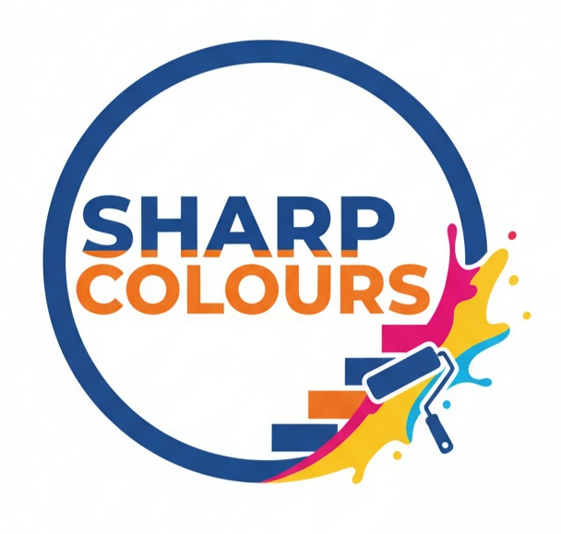
Creative & Professional Painting Solutions
ADD- Gurukrupa Society, Yamuna Heights, Mundhava, Old Orbis School Road, Keshavnagar, Pune – 411036
Website: Https://www.sharpcolours.in
Email: info@sharpcolours.in
Mobile No. 9523031749 Date:

